FSE-4 ACCREDITION

Sajith Sathiadevan :297655

Skill Tracker

Design Document

1. **Urls**

|  |  |
| --- | --- |
| **Name** | **URL** |
| **Command Service URL** | **http://Skillcmdapp-env.eba-bpxjbh4d.us-east-2.elasticbeanstalk.com/api/v1/engineer/** |
| **Query Service URL** | **http://skillprofilecmdapp-env.eba-pajjh5f2.us-east-2.elasticbeanstalk.com/api/v1/admin** |
| **Front End URL** | **http://myskillprofilebucket.s3-website.us-east-2.amazonaws.com/** |

1. **Api Backend Flow Architecture**

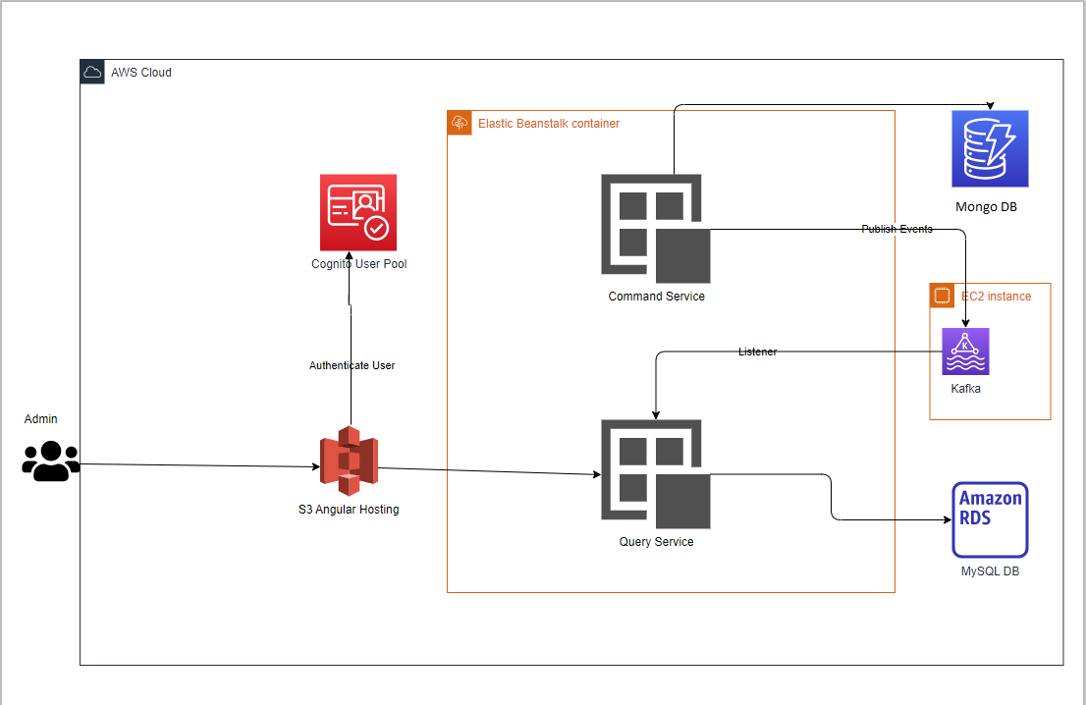

1. **UI Flow Architecture**

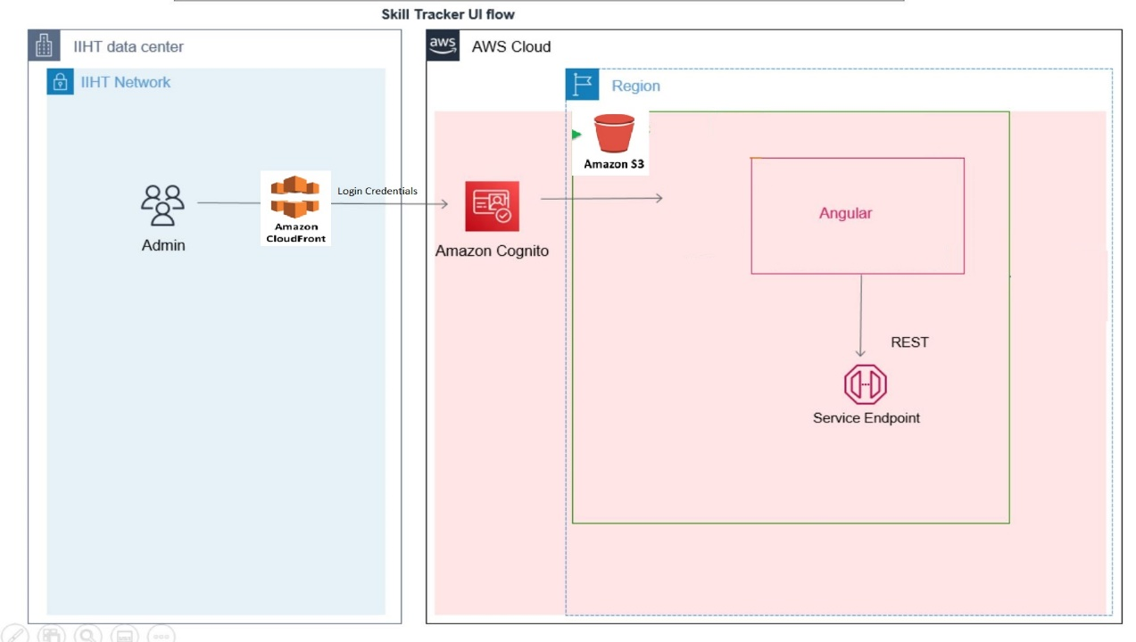

1. **UI Application Screen Shot**

**Login page**

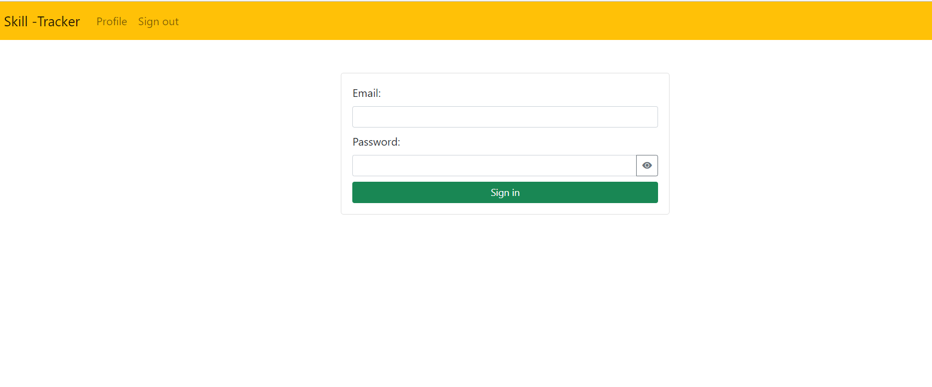

**Search screen**

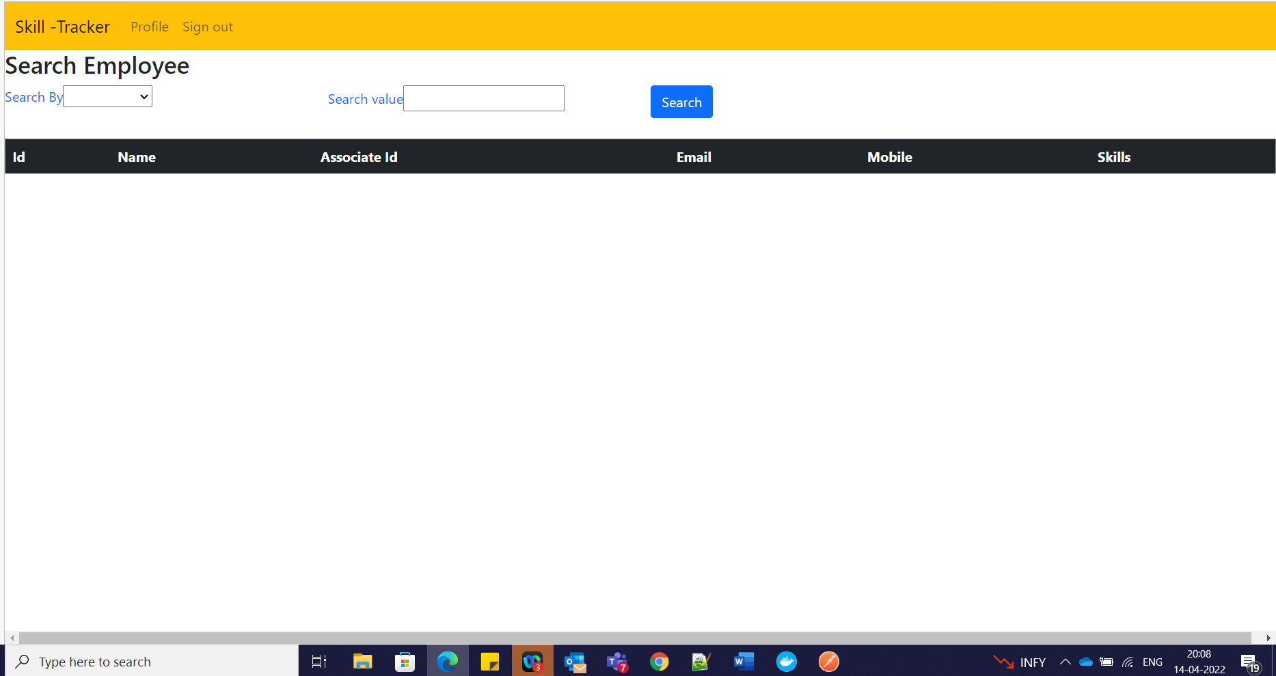

**Search Display**

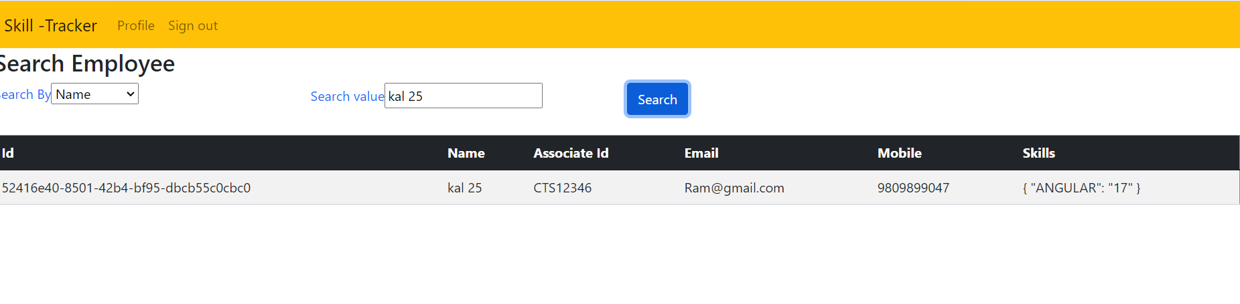

* **Testing Via Post man**

